Prepared For: | Atlanta Public Schools
Prepared By: | Tyler Cade

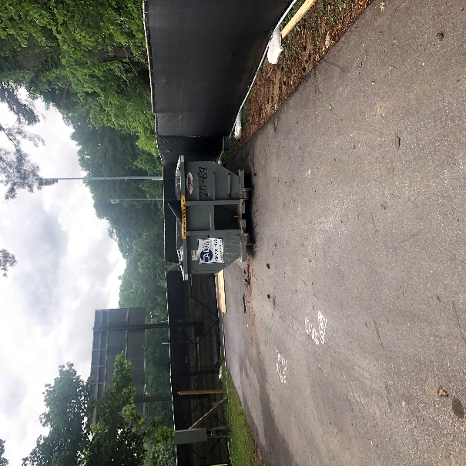 | 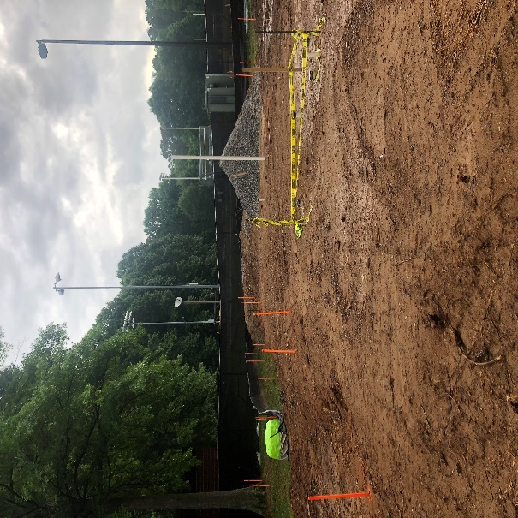
Site Dumpster | Building Pad and Plumbing Rough In
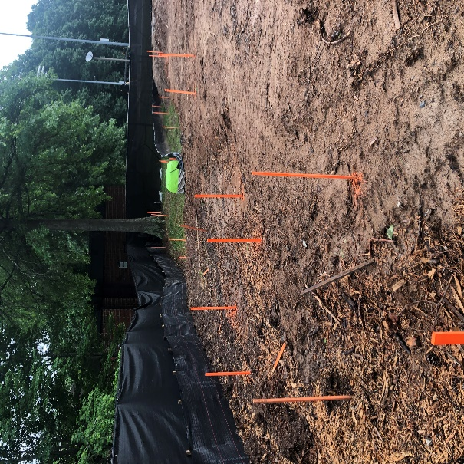 | 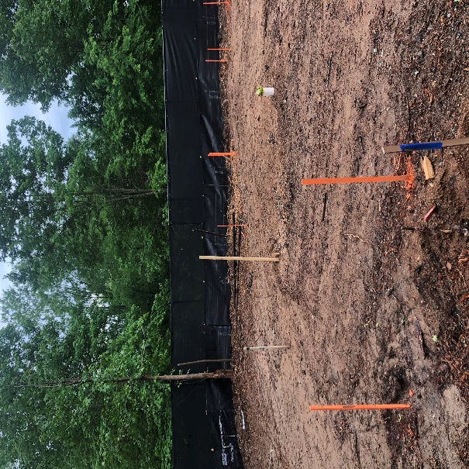
Retaining Wall Layout | Retaining Wall Layout

Last Week’s Activities:

- Completed temporary utilities
- Continued MEP slab rough in
- Continued plumbing slab inspections
- Started footing excavations
- Started footing inspections
- Started footing concrete pours
- Started slab on grade prep

This Week’s Activities:

- Continued MEP slab rough in
- Continued plumbing slab inspections
- Continued footing excavations
- Continued footing inspections
- Continued footing concrete pours
- Continued slab on grade prep
- Started slab inspections
- Started slab on grade concrete pours

Next Week’s Activities:

- Continue MEP slab rough in
- Continue plumbing slab inspections
- Continue footing excavations
- Continue footing inspections
- Continue footing concrete pours
- Continue slab on grade prep
- Continue slab inspections
- Continue slab on grade concrete pours
- Start CMU block installation

Contract & Billings  Contract  Current Contract Value  Billings  Date Last Billing Submitted  Total Billed to Date (Including Retainage)  Date of Last Payment  Amount Paid to Date  Amount Open Receivables (Not Including Retainage)  Percent Billed to Date | $1,477,751  5/10/2022  $107,692.23  N/A  $0  $96,923.01  7%

